Lab 7: Controlling Application Usage with App-ID

Name:
Jobayer Bhuiyan

Purpose:
The purpose of this lab is to demonstrate how to control application usage using App-ID on a Palo Alto Networks firewall. The lab involves creating an application group, configuring security policies to allow specific applications, identifying rule shadowing issues, testing with App Generator, and viewing logs to verify traffic behavior.

Logical Network Drawing:

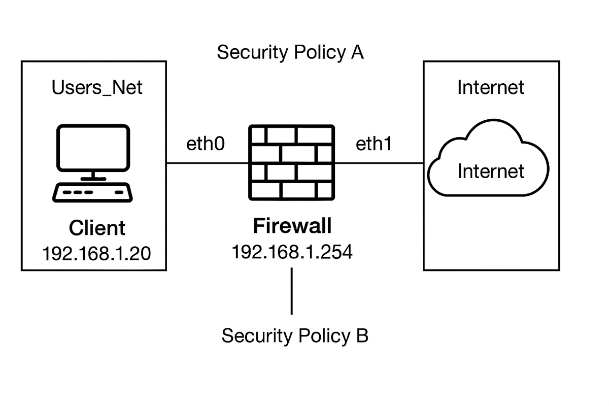

Address Table:
Device | IP Address | Notes
Client | 192.168.1.20 | Source for test traffic
Firewall | 192.168.1.254 | Management Interface
Internet | N/A | Destination for testing

Procedures:
- Load Base Configuration
  - Loaded edu-210-11.0a-07.xml configuration from Device > Setup > Operations.
  - Committed configuration successfully.
- Create Application Group
  - Created paloalto-apps group under Objects > Application Groups.
  - Included applications: paloalto-dns-security, paloalto-updates, paloalto-userid-agent, paloalto-wildfire-cloud, and pan-db-cloud.
- Create Security Rule: Allow-PANW-Apps
  - Created rule under Policies > Security.
  - Source Zone: Users_Net, Source Address: 192.168.1.254
  - Destination Zone: Internet, Destination Address: any
  - Application: paloalto-apps, Service: application-default
  - Action: Allow, Logging enabled at session end.
- Initial Testing and Troubleshooting
  - Performed Dynamic Updates > Check Now
  - Traffic logs showed application paloalto-updates matched Users_to_Internet (not our new rule).
  - Rule was being shadowed.
- Identify and Resolve Rule Shadowing
  - Used Tasks > Commit > Rule Shadow tab to identify shadowing.
  - Moved Allow-PANW-Apps rule above Users_to_Internet.
  - Recommitted configuration.
- Retest and Verify Logs
  - Dynamic Update triggered again.
  - Verified in Traffic Logs that Allow-PANW-Apps rule was now matched.
- Run App Generator
  - Launched App Generator on Client.
  - Observed traffic for non-DNS applications.
- Review App Generator Traffic
  - Used traffic log filter: (addr.src in 192.168.1.20) and (app neq dns).
  - Verified various application traffic behavior.
- Research Application: Dailymotion
  - Located dailymotion in Objects > Applications.
  - Recorded application details (Category: media, Risk: 5, Ports: TCP 80/443).
- Update Security Policies for App Control
- Edited Users_to_Extranet to allow: ssl, ssh, ping, dns, ldap, radius, web-browsing
- Edited Users_to_Internet to allow: ping, dns, ssl, yelp, web-browsing, dropbox, ms-office365 (and all dependencies).
- Committed changes.
- Final Testing with Block Page
- Accessed http://www.shutterfly.com to confirm application was blocked.
- Enabled Application Block Page from Device > Response Pages.
- Re-tested shutterfly.com and saw Palo Alto block message.

Troubleshooting / Verification Table:
Step | Check | Result/What to Expect
4 | Traffic log shows wrong rule matched | Rule shadowing present
5 | Rule moved above others | Shadowing resolved
6 | Log show Allow-PANW-Apps used | Verification of fix
8 | Logs show no-DNS apps after generator | Confirms generator traffic
9 | App info shows category,risk,ports | Used in policy decisions
11 | Block page visible | Confirms block page working as expected

